**PROPOSAL (Draft):**

**Summer activities**

**for Chesterton Academy Students**

**WHEN: June, July, Aug 2024**

**WHERE: Queen of Heaven, School? Gym? Parish Hall?**

**WHO: Chesterton Academy Students, supervised and directed by adults.**

**WHAT: Primarily a Tech oriented program: Engineering, Computer Programming, and Robotics/Drones**

**1) Engineering will center around “Designing, Drafting and Building an 8-bit Computer from Logic Chips (74LS-- series of Integrated Circuits).**

**a) Design:**

***i*) software: ‘Digital’ by H Neemann**

**goto** [**https://github.com/hneemann/Digital**](https://github.com/hneemann/Digital) **, click on ‘code’ and download zip if you want to try it out!**

***ii)* Example:Minus (Input, RAM, Instruction Reg, and Control)**

**‘B’ Register**

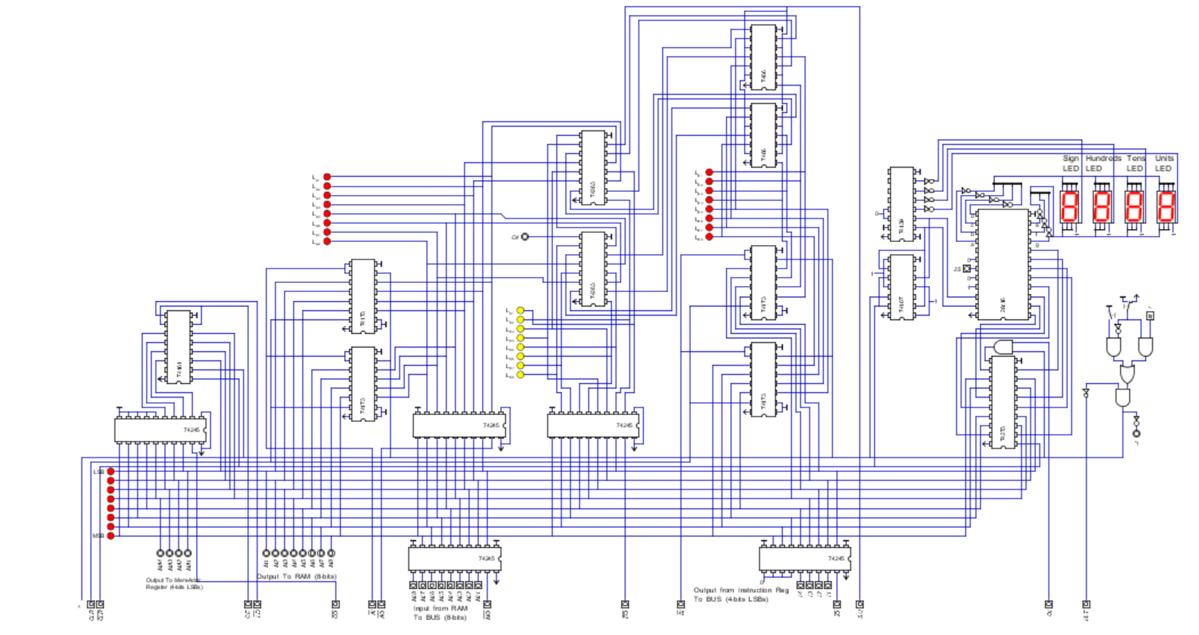

**Arithmetic**

**Logic Unit Output**

**A’ Register**

**‘**

**Program**

**Counter Clock**

**b) Draft (from ‘design to Schematic)**

***i)* Software: Fritzing:** [**https://fritzing.org/**](https://fritzing.org/)

**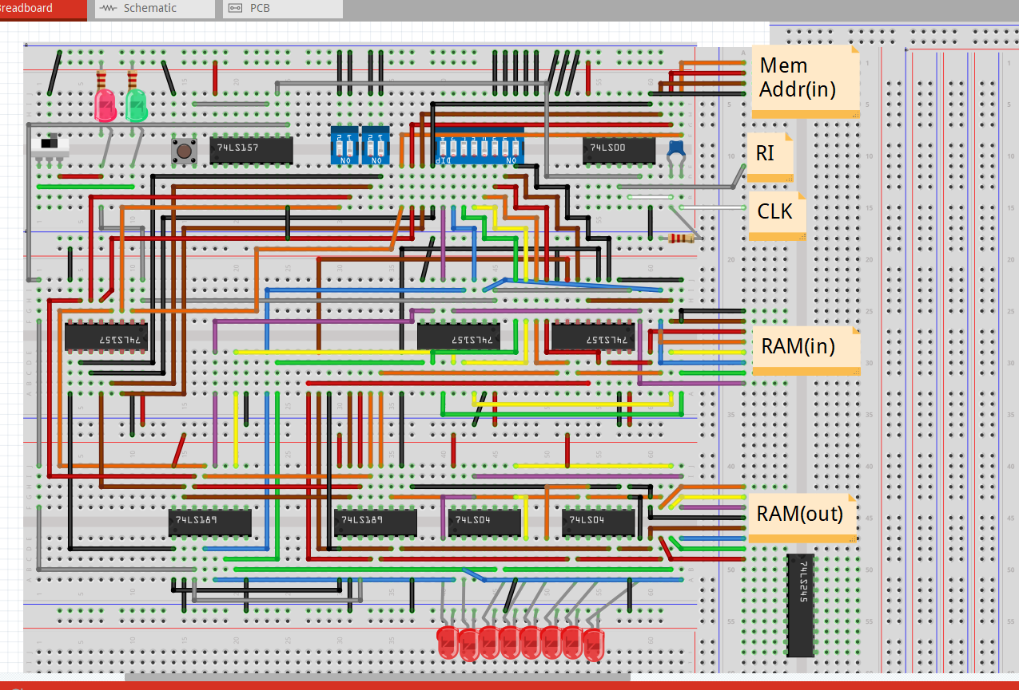*ii)* Example**

**c) Build (from Schematic to actual build)**

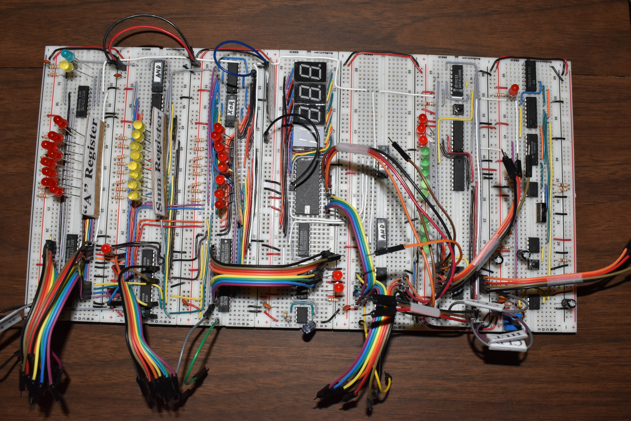

**See all Ben Eater’s videos on building an 8-bit computer**

[**https://www.youtube.com/playlist?list=PLowKtXNTBypGqImE405J2565dvjafglHU**](https://www.youtube.com/playlist?list=PLowKtXNTBypGqImE405J2565dvjafglHU)

**2) Computer Programming**

**a) Programming EEPROMs in 1) above will be done on the Arduino Micro controller in the C/C++ language.**

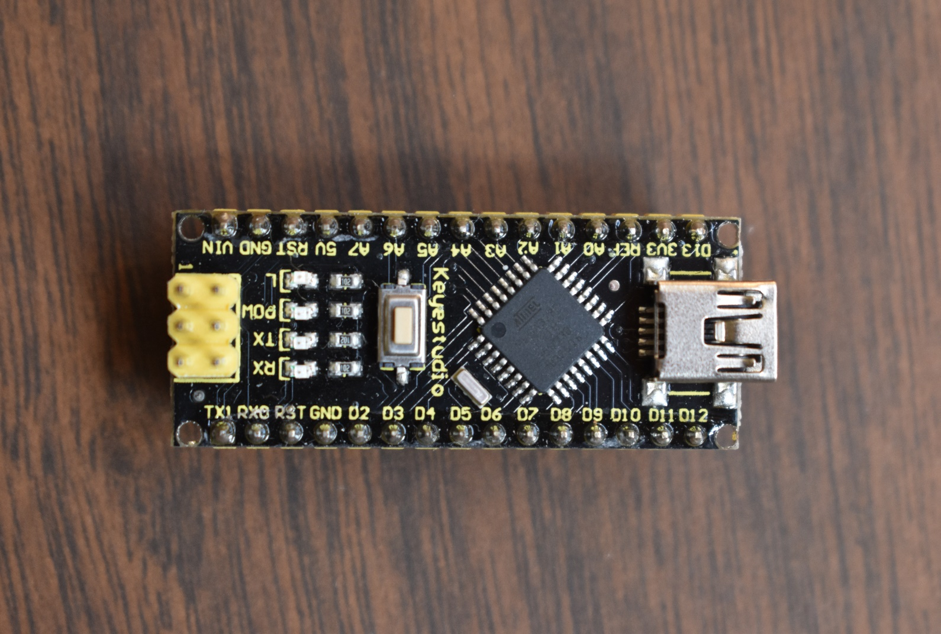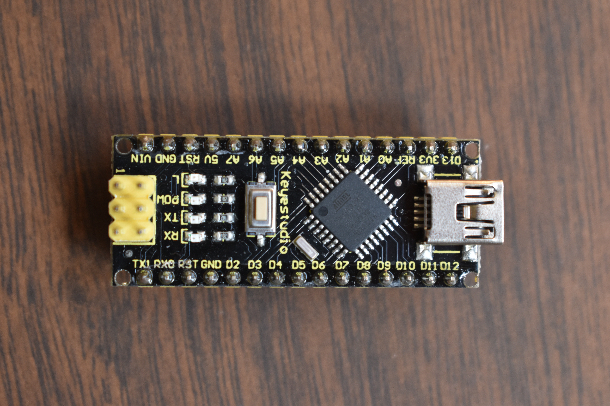

**b) Web and Game Development could also be included and would be done in JavaScript, HTML, and CSS.**

**One option would be to develop a Company Web site for Project 1) above and could use the following as a frame work on which to add text, images & videos of their work through out the summer:**

[**https://design-build-educate.github.io/DBE_Inc/**](https://design-build-educate.github.io/DBE_Inc/)

**For those interested in ‘Game Development’ I think the following program on youtube would be a good choice!**

**JavaScript Game Development Course for Beginners**

**Learn to make 2D games with HTML, CSS & plain vanilla JavaScript, no frameworks and no libraries! From sprite animation to state management, in this series of projects you will learn everything you need to make your own 2D animated games! We will go step by step explaining each technique on a small standalone codebase and then we will use everything we learned to make a single final game. ✏️**

**Course by Frank's Laboratory.**  [** / frankslaboratory**](https://www.youtube.com/c/Frankslaboratory)

**3) Robotics/Drones would include:**

**a) “remote controlled” as well as “autonomous” flight.**

**b) A special project: Create “Obstacle Courses” involving the use of both Robots and Drones.**

**GOALS:**

**1) Student Enrichment: With Chesterton Academy’s emphasis on “Scholasticism”, it is assumed that Tech, especially Computer related skills, will be picked up outside of Class time.**

**2) If possible, time permitting at the end of summer vacation (eg 2 weeks), the High School students could design and then host and run a summer program for their siblings, which could definitely include activities described above.**

**I am a certified teacher on code.org and have computer classes set up for youth starting as young as kindergarten!**

**Let me know if you would like to give it a try!** [**Learn today, build a brighter tomorrow. | Code.org**](https://code.org/) **If some parents would like to have their little ones try this out I’m sure we could work it into the schedule.**

**3) Another option would be for the above students to design and run a similar project during the summer of 2025 for disadvantaged students. For example:**

**a) Students from the Native American Community Academy (NACA) here in Albuquerque**

**b) Lakota Students from Eagle Butte, SD on the Cheyenne River Indian Reservation in Eagle Butte, SD. They can stay all summer at the Cheyenne River Youth Program (** [**https://lakotayouth.org**](https://lakotayouth.org/) **)**

**Remember this is just a draft and only some of my thoughts. I would really like to hear from anyone else on suggestions they might have.**